|  |  |  |
| --- | --- | --- |
|  | **Rochester Institute of Technology**  **Golisano College of Computing and Information Sciences**  **School of Interactive Games and Media**  **2145 Golisano Hall – (585) 475-7680** |  |

**Data Structures & Algorithms for Games & Simulation II**

**IGME 309**

**Visual Studio SFML Configuration**

This exercise follows lecture D02

1. In the root of the repository look for the solution file and open it in the most current version of visual studio, if while opening it, it asks to update your file to a newer version of the SDK, do so.

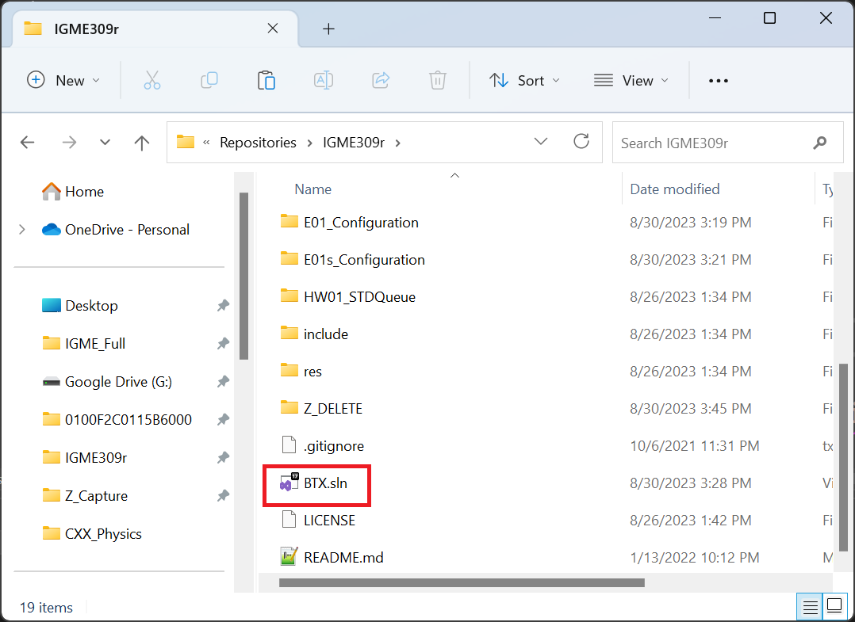

1. Once inside visual studio, locate the exercise in the list of projects, right click on it and make sure it is marked as the startup project.

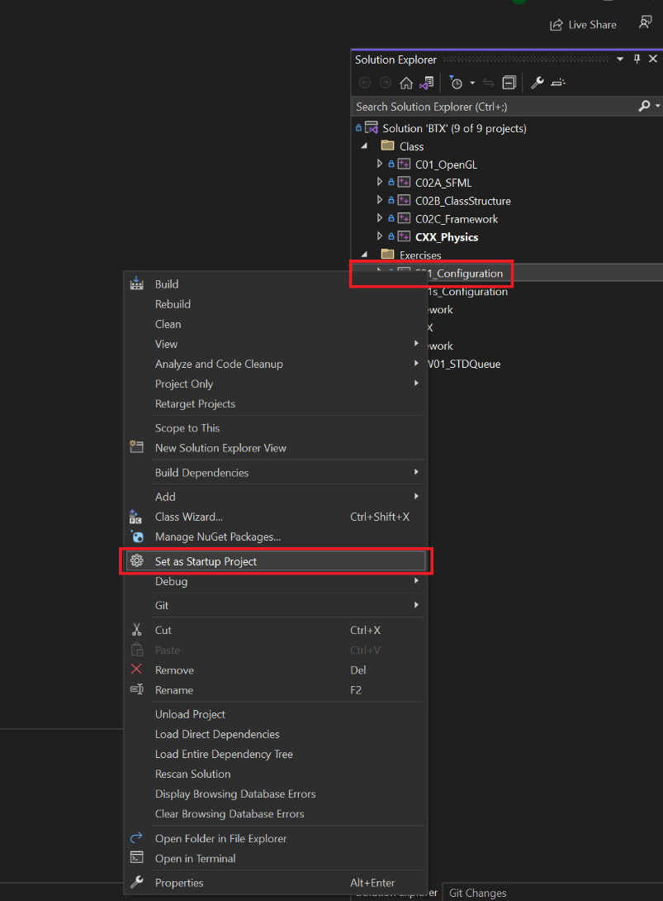

1. Open the main.h file

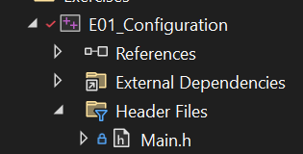

and replace the content with the following.

#ifndef __MAIN_H_

#define __MAIN_H_

#include <stdio.h>

#include <stdlib.h>

#include <GL\glew.h>

#include <GL\wglew.h>

#include <SFML/Window.hpp>

#include <SFML/OpenGL.hpp>

#endif //__MAIN_H_

1. Select the file Main_To_Replace.cpp and delete it

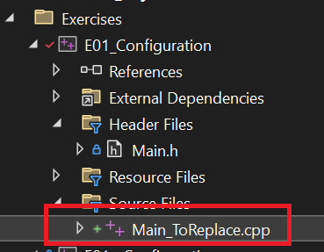

1. Right-click on the now empty “Source Files” folder and add an existing file:

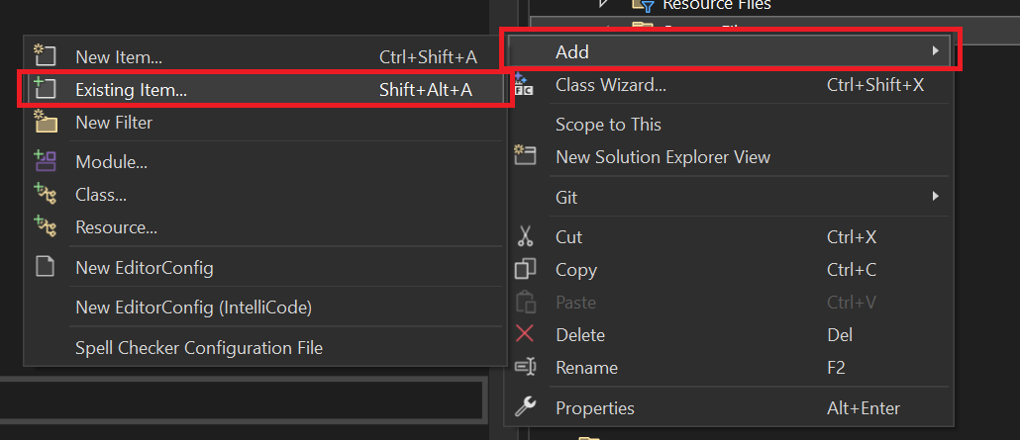

1. The file that you are looking for is called Main.cpp

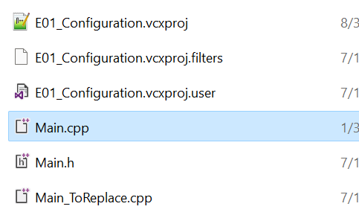

If you try to compile this now it will fail because the necessary libraries have not been linked yet. We will fix that next.

1. Once more right-click on the project as you did for setting it up, but this time look for properties at the bottom

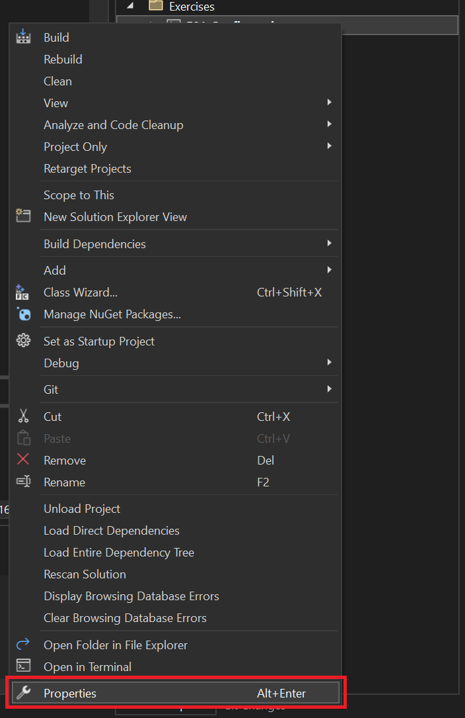

1. Make sure the configuration that we will work with is done for debug and a windows 32bit system:

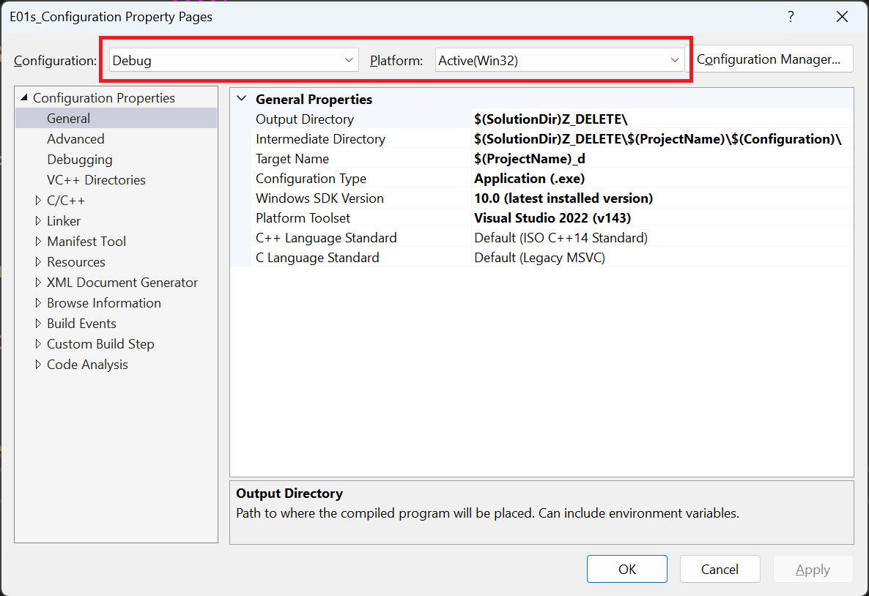

1. In VC++ directories we will change the following:
   1. Executable Directories will be replaced with: $(SolutionDir)include\GL\bin;$(SolutionDir)include\SFML\bin;$(ExecutablePath)
   2. Include Directories will be replaced with: $(SolutionDir)include;$(SolutionDir)res;$(IncludePath)
   3. Library Directories will be replaced with: $(SolutionDir)include\GL\lib;$(SolutionDir)include\SFML\lib;$(LibraryPath)

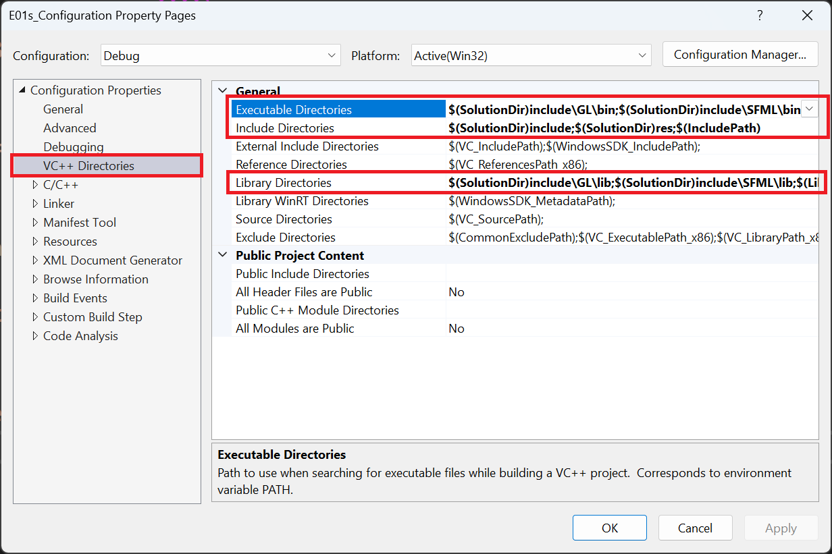

This will tell visual studio where are the necessary header, dll and lib files that are required to compile the application using the libraries

1. In Linker/Input we need to change the following on Additional Dependencies: glu32.lib;glew32.lib;opengl32.lib;sfml-system-d.lib;sfml-window-d.lib;sfml-graphics-d.lib;%(AdditionalDependencies)

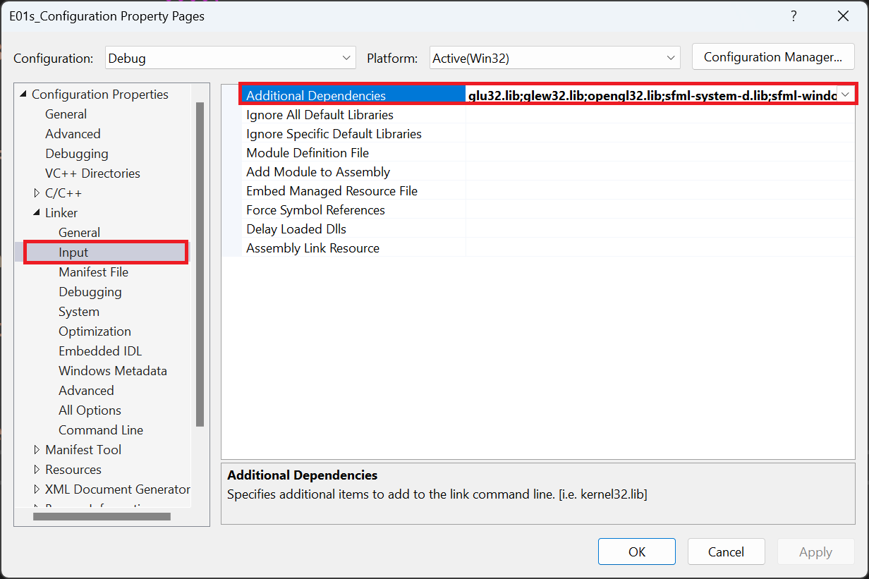

This will tell our application what files we are using, there is a completely different set of files for a release version, and our provided solution is already configured for us, while necessary if we want to compile to distribute the .exe of our application, it is not needed for this exercise. Many libraries use the -d or _d at the end of a file to indicate that is a debug version of their libraries.

1. After everything is set up, just hit OK in the configuration and run your application with F5 (Do not use Ctrl + F5 as this will prevent some things to run in Visual Studio for our libraries).

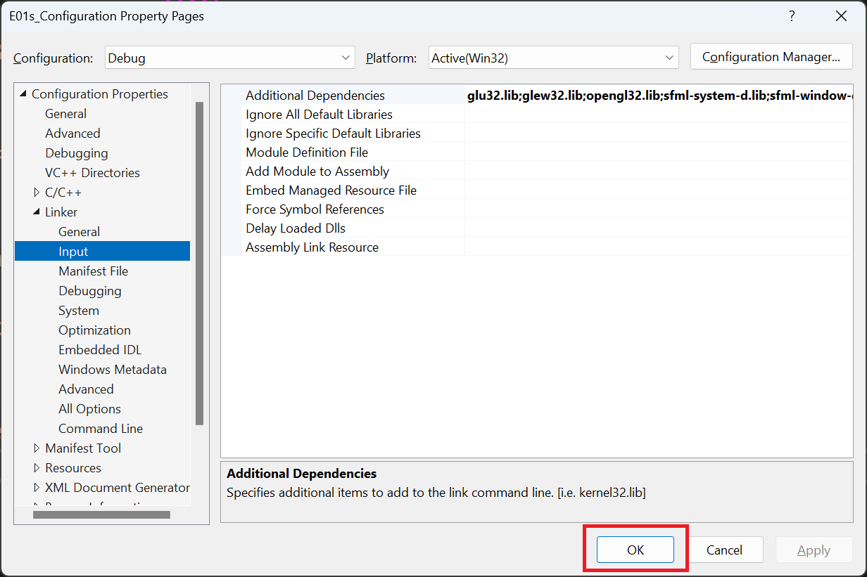

1. If done correctly your application will show the following window alongside a command line:

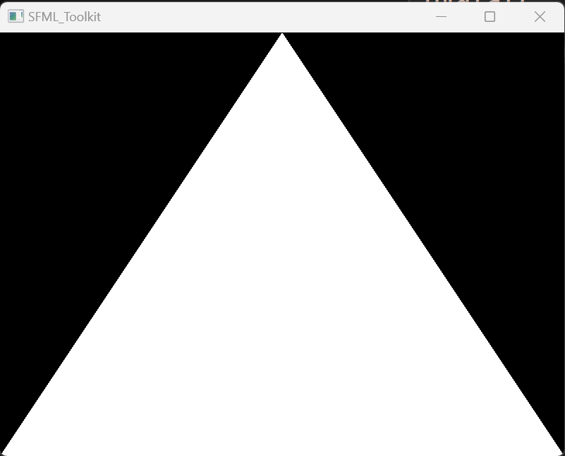

1. Zip the following files for your submission:

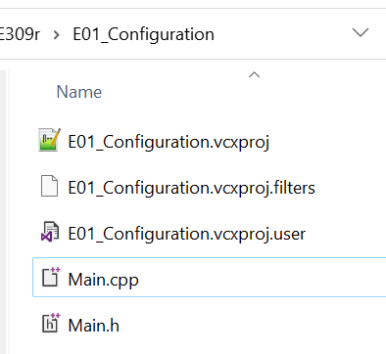

These files are what we know as your Project, do not confuse this with your Solution, a Solution is a collection of projects. For most of the assignments that you will create for the rest of the semester this is what we need for a submission. Your 3 vcxproj files alongside with all .h and .cpp files you need to use the application.

1. Submit this to the dropbox in MyCourses and push to your repository for the class.